Spatial domain maps for Mouse Brain Anterior and Human Lymph Node
Figure 1 shows side-by-side spatial maps of the ground-truth annotations and the domain assignments produced by GatorST and competing baseline methods, along with the corresponding ARI values. On both datasets, GatorST attains the highest ARI (mouse brain anterior: 0.483; human lymph node: 0.308) and generates domain patterns that are visually more spatially contiguous and consistent with the ground-truth tissue organization.
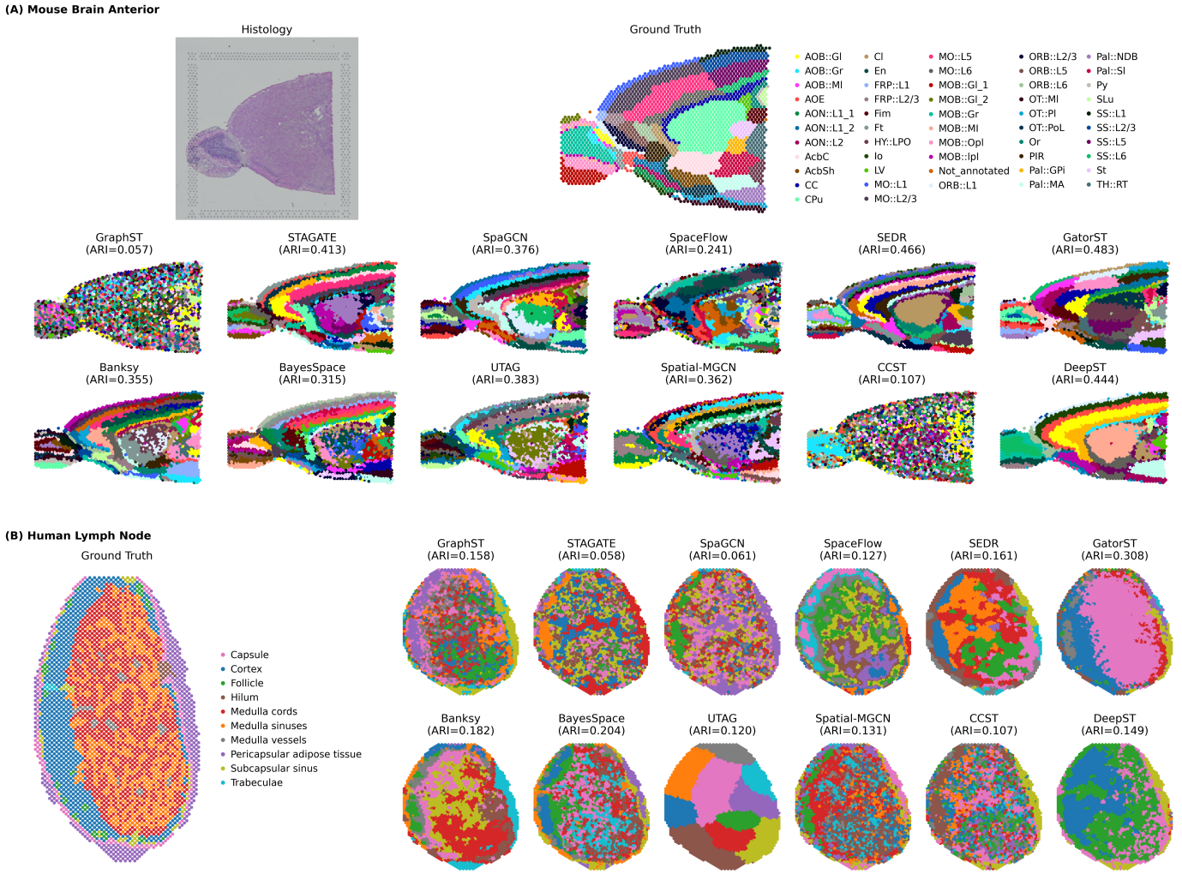
Figure 1：Spatial domain benchmarking on Mouse Brain Anterior and Human Lymph Node. (A) Mouse Brain Anterior: histology image and the ground-truth anatomical annotations (top), followed by spatial domain assignments inferred by GatorST and competing baseline methods (bottom). (B) Human Lymph Node: ground-truth region annotations (left) and inferred spatial domains by each method (right).

Marker and Boundary DEG/GO Validation on DLPFC Section 151674
Figure 2 provides an overview of spatial domain identification and boundary validation on DLPFC section 151674. Panels A–C evaluate domain delineation and agreement with manual annotations (predicted domains in A and the contingency matrix in C), while panels D–E validate the biological identity of each domain using canonical cortical-layer and white-matter markers. Panels B and F visualize boundary spots (global boundaries in B, and the L6–WM interface boundaries highlighted in F). We defined spatial domain boundaries using only the GatorST’s predicted labels and the 2D spot coordinates: we built a k-nearest-neighbor (kNN) graph from spot locations using Euclidean distance (k = 5) and marked a spot as a boundary spot if at least one of its k nearest neighbors (excluding itself) had a different predicted domain label. Panels G–H then characterize boundary-associated transcriptional shifts at the L6–WM interface via boundary-focused differential expression (DE) and Gene Ontology (GO) enrichment analyses.
On DLPFC section 151674, GatorST delineated seven spatial domains corresponding to cortical layers (L1–L6) and white matter (WM), achieving an ARI of 0.731 against manual annotations (Figure 2A–2C). The row-normalized contingency matrix showed high domain purity for L1 (99%), L4 (97%), L5 (98%), L6 (92%), and WM (98%), with the main ambiguity observed between adjacent superficial layers (L2/L3) (Figure 2C). Canonical laminar and WM markers further supported the biological identity of these domains: RELN (Reelin) was enriched in superficial cortex and MOBP (a myelin/oligodendrocyte marker) was enriched in WM, while CALB1/PCP4 and NEFH showed layer-biased patterns across upper and deep layers (Figure 2D–2E).
To further interpret domain boundaries, we focused on boundary spots along the L6–WM interface (Figure 2F) and performed boundary-focused differential expression (DE) analysis comparing L6-side versus WM-side boundary spots. This analysis identified neuronal-associated differentially expressed genes (DEGs, e.g., OLFM1, ENC1, VSNL1) on the L6 side and myelination/oligodendrocyte-associated DEGs (e.g., MBP, PLP1, MOBP) on the WM side (Figure 2G). Gene Ontology (GO) enrichment of boundary DEGs further highlighted calcium/ion-transport and neurite-related processes on the L6 side, whereas myelination and oligodendrocyte development/differentiation terms were enriched on the WM side (Figure 2H). Together, these results indicate that GatorST captures biologically meaningful transitions at spatial domain boundaries.
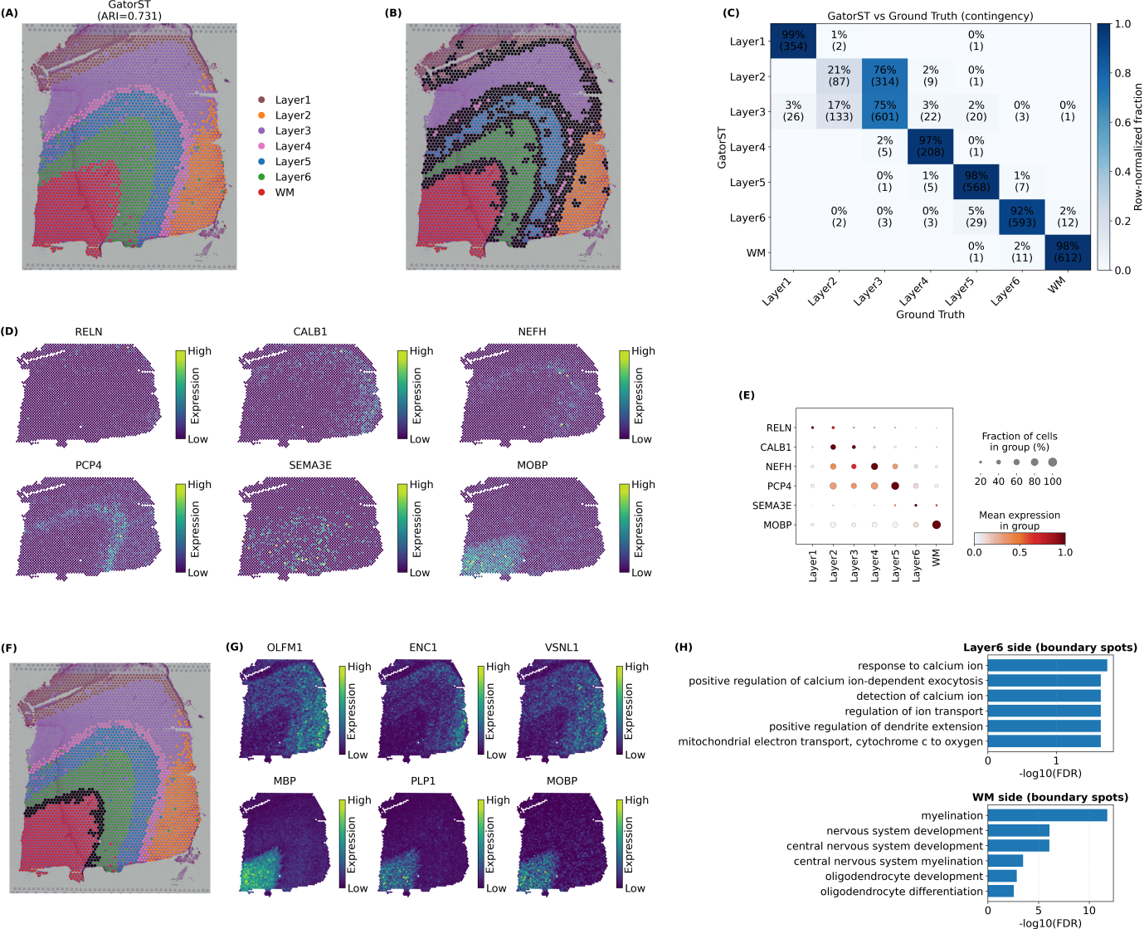
Figure 2: Boundary interpretation on DLPFC section 151674. (A) GatorST-predicted spatial domains (L1–L6 and WM). (B) Boundary spots identified from predicted labels using a kNN graph on 2D spot coordinates (k = 5; label disagreement with ≥1 neighbor). (C) Row-normalized contingency matrix comparing predicted domains with manual layer/WM annotations. (D–E) Canonical laminar and WM markers validate domain identities. (F–H) Boundary analysis at the L6–WM interface: (F) interface boundary spots, (G) boundary DEGs, and (H) GO enrichment, highlighting neuronal signatures in L6 versus myelination/oligodendrocyte signatures in WM.

Robustness across episodic configurations
To evaluate the sensitivity of GatorST to the episodic meta-learning configuration, we varied the N-way M-shot setting with $N,M∈\left\{3,4,5,6,7\right\}$and assessed performance on two representative datasets from different platforms: the Visium DLPFC slice 151676 and the Stereo-seq E9.5 mouse embryo dataset (as shown in Figure 3). Overall, the performance patterns were relatively stable across a range of episodic configurations, suggesting that GatorST is robust to moderate changes in $N$and $M$. On the Visium dataset, the strongest overall performance was observed when $M=3$, with $N=5$yielding the highest NMI, ACC, and Purity and near-best ARI and Homogeneity. On the Stereo-seq mouse embryo dataset, performance was likewise consistently strong across multiple settings, with $N=5$and $M=3$achieving the highest NMI and Homogeneity, tied-best Purity, and near-best ARI and ACC. Taken together, these results indicate that a moderate N-way, low-shot episodic design provides a favorable balance between performance and robustness across platforms.
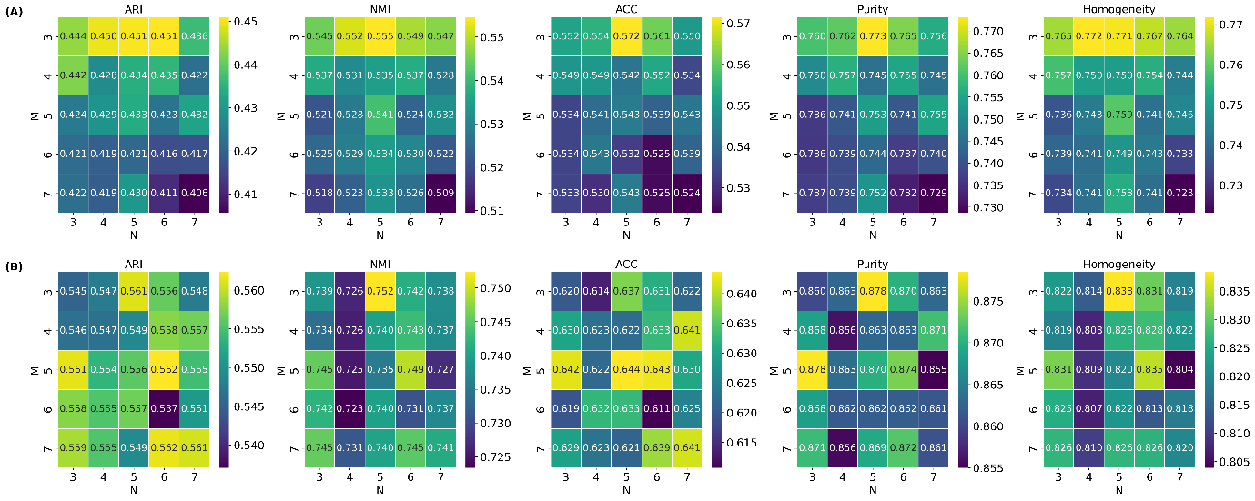
Figure 3: Sensitivity analysis of the N-way M-shot episodic design. Heatmaps show ARI, NMI, ACC, Purity, and Homogeneity under different episodic configurations with $N,M∈\left\{3,4,5,6,7\right\}$on representative Visium dataset (151676; panel A) and Stereo-seq dataset (E9.5 mouse embryo; panel B). Higher values indicate better performance for all metrics.

Table 1. Notation used in GatorST
Notation | Definition
$$G$$ | Spot-spot graph representing spatial transcriptomic data.
$$V$$ | Set of nodes/spots in the spot-spot graph.
$$ℰ$$ | Set of edges connecting neighboring nodes in the spot-spot graph.
$$X$$ | Gene-expression matrix of all spots after preprocessing.
$$A$$ | Adjacency matrix encoding the connectivity of the spot-spot graph.
$$s\left(v_{i},v_{j}\right)$$ | Similarity score between nodes $v_{i}$ and $v_{j}$, computed from their spatial locations.
$$G_{v}$$ | Two-hop local subgraph centered at node $v$, used for subgraph-based representation learning.
$$V_{v}$$ | Set of nodes contained in the local subgraph $G_{v}$.
$$ℰ_{v}$$ | Set of edges contained in the local subgraph $G_{v}$.
$$X_{v}$$ | Gene-expression matrix associated with the nodes in the local subgraph $G_{v}$.
$$N_{v}$$ | Set of two-hop neighboring nodes of node $v$.
$$d\left(v,u\right)$$ | Shortest-path distance between nodes $v$ and $u$ in the spot-spot graph.
$$h_{v}$$ | Learned representation of node $v$.
$$K$$ | Number of clusters used in soft $K$-means pseudo-labeling.
$$y_{i}$$ | Hard pseudo-label assigned to node $i$ after soft clustering.
$$S$$ | Support set in an episodic meta-training task.
$$Q$$ | Query set in an episodic meta-training task.
$$T$$ | Meta-training tasks are constructed from the support set and query set in episodic training.
$$N$$ | Number of randomly sampled classes in an N-way episodic task.
$$M$$ | Number of sample nodes per class in the support set (i.e., M-shot).
$$τ$$ | Temperature parameter in the contrastive objective, controlling the sharpness of the similarity distribution.

